6.Multiple Tables and Joins

4-5-23

1. select * from LMS_MEMBERS;
2. select * from LMS_BOOK_DETAILS;
3. select * from LMS_fine_details;
4. select * from LMS_BOOK_ISSUE;
5. select * from LMS_SUPPLIERS_DETAILS;

Q1) Write a query to display total fine amount paid by members (select

Member_ID, Member_Name, City, Membership_status, Fine amount)

Ans.

Attempt 1.

TABLES LINK

select * from LMS_MEMBERS;

-MEMBER_ID

select * from LMS_BOOK_DETAILS;

-MEMBER_ID

-FINE_RANGE.

select * from LMS_fine_details;

-FINE_RANGE

SO WE LINK TABLE 1 WITH 2 AND 2 WITH 3.

SELECT M.Member_ID, M.Member_Name, M.City, M.MEMBERSHIP_STATUS, SUM(fd.Fine_amount)

FROM LMS_MEMBERS M

INNER JOIN LMS_BOOK_DETAILS BD

ON M.MEMBER_ID=BD.MEMBER ID

INNER JOIN LMS_FINE_DETAIL FD

ON BD.FINE_RANGE = FD.FINE_RANGE

GROUP BY M.MEMBER_ID, M.MEMBER_NAME, M.CITY, M.MEMBERSHIP_STATUS;

error=”SQL command not properly ended”

Mistake

i used member, book details and fine details tables instead of members, book details, book issue.

Answer provided

SELECT lms_members.MEMBER_ID,

lms_members.MEMBER_NAME,lms_members.CITY,lms_m

embers.MEMBERSHIP_STATUS,

SUM(lms_fine_details.FINE_AMOUNT)

FROM lms_members

JOIN lms_book_issue ON (lms_members.MEMBER_ID =

lms_book_issue.MEMBER_ID)

JOIN lms_fine_details on(lms_book_issue.FINE_RANGE =

lms_fine_details.FINE_RANGE)

GROUP BY lms_members.MEMBER_ID,

lms_members.MEMBER_NAME,lms_members.CITY,lms_m

embers.MEMBERSHIP_STATUS;

Error “FROM keyword not found where expected”

Attempt 2.

Tables

LMS_MEMBERS-Member_ID, Member_Name, City, MEMBERSHIP_STATUS (MEMBER_ID)

LMS_BOOK_ISSUE- (MEMBER_ID)(FINE_RANGE)

LMS_FINE_DETAILS- FINE_AMOUNT (FINE_RANGE)

SELECT M.Member_ID, M.Member_Name, M.City, M.MEMBERSHIP_STATUS, SUM(FD.FINE_AMOUNT)

AS Total_Fine_Amount

FROM LMS_MEMBERS M

LEFT JOIN LMS_BOOK_ISSUE BI

ON M.Member_ID = BI.Member_ID

LEFT JOIN LMS_FINE_DETAILS FD

ON BI.FINE_RANGE = FD.FINE_RANGE

GROUP BY M.Member_ID, M.Member_Name, M.City, M.MEMBERSHIP_STATUS

ORDER BY Total_Fine_Amount;

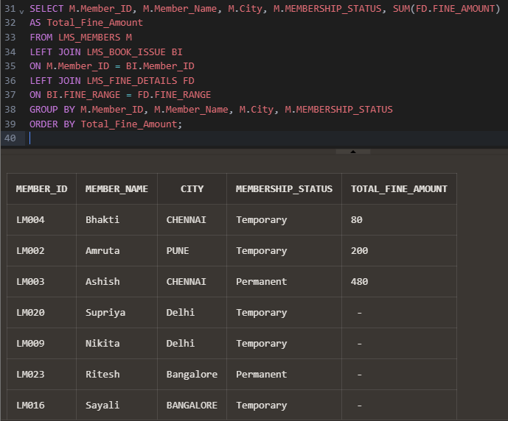

FROM keyword not found where

Q2) Write a query to display the members who have issued more than

4 books. (Select member ID, member name and count of books)

Ans.

TABLES LINK

select * from LMS_MEMBERS;

-**MEMBER_ID**

**select * from LMS_BOOK_ISSUE;.**

**-MEMBER_ID**

**QUERY=**

**SELECT M.Member_ID, COUNT(M.Member_ID), M.Member_Name**

**FROM LMS_MEMBERS M**

**INNER JOIN LMS_BOOK_ISSUE BI**

**ON M.Member_ID=BI.MEMBER_ID**

**GROUP BY M.Member_ID, M.Member_Name**

**HAVING COUNT(M.Member_ID)>4;**

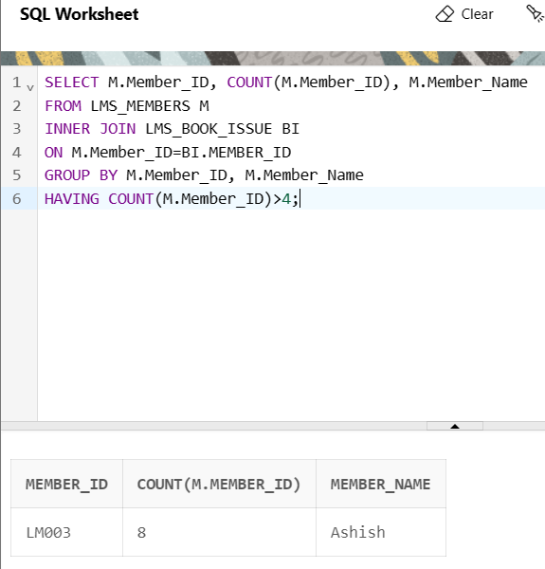

Q3) Write a query to display the book_code from lms_book details

table, Book_title, Date_issue from lms_book_issue. If date_issue is null

then display "No" else display "Yes" with alias Availability Status.

Ans.

TABLE LINK

lms_book details -BOOK_CODE

lms_book_issue--BOOK_CODE

SELECT BD.BOOK_CODE, BI.BOOK_TITLE,

CASE

WHEN BI.DATE_ISSUE IS NULL THEN 'No'

ELSE 'Yes'

END AS AVAILABILITY_STATUS

FROM LMS_BOOK_DETAILS BD

INNER JOIN LMS_BOOK_ISSUE BI

ON BD.BOOK_CODE=BI.BOOK_CODE

GROUP BY BD.BOOK_CODE, BI.BOOK_TITLE, BI.DATE_ISSUE;

ERROR

"BI"."BOOK_TITLE": invalid identifier

It seems that the lms_book_issue table does not have a column called book_title. Please check the column name and ensure that it exists in the table. If it doesn't, you may need to modify your query to join with a different table that contains the book_title information.

Attempt 2.

Points-

1.In the given scenario, if the book is issued, the AVAILABILITY_STATUS should be 'No' because it is not available but the question statement tells the viceversa so it's logically incorrect.

2.The placement of the CASE statement at the beginning of the SELECT clause is just a conventional style,

SELECT BD.BOOK_CODE, BD.BOOK_TITLE,

CASE WHEN BI.DATE_ISSUE IS NULL THEN 'No'

ELSE 'Yes' END AS AVAILABILITY_STATUS

FROM LMS_BOOK_details BD

LEFT JOIN LMS_BOOK_ISSUE BI

ON BD.BOOK_CODE = BI.BOOK_CODE

GROUP BY BD.BOOK_CODE, BD.BOOK_TITLE, BI.DATE_ISSUE;

